
Year 10
Pathway 2

Mini Test - Simultaneous Equations

Total Marks: 30 marks
Name: ______________________ Total Time: 30 minutes

Show working and answers on this sheet. Show working in sufficient detail to support your answers. Incorrect answers without supporting reasoning may be allocated zero marks.

Resources allowed: 1 page of notes A4, 1 side. Calculator

- Determine the point of intersection for the following pairs of simultaneous equations.

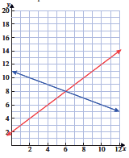
(1 mark)

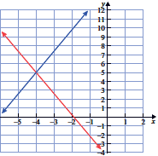
(1 mark)

- Sketch the graphs with equations
x – y = 2 and 2x + y = 1 accurately on the set of axes provided.
- Solve the equations graphically by stating the x and y values at the point
of intersection.
- Solve the equations simultaneously (algebraically) and verify your graphical answer.

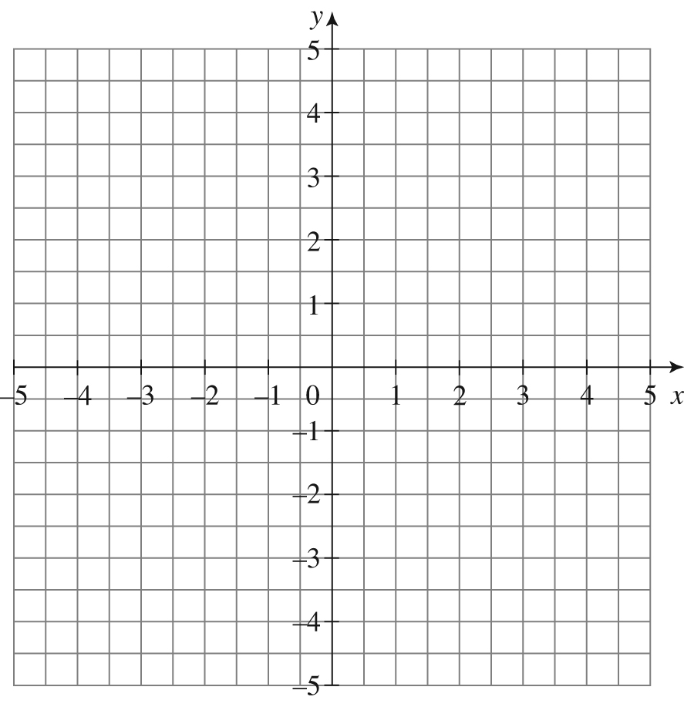

(5 marks)

- Find the solution to the following pairs of simultaneous equations by substitution.
- $3a+b=8$
$$b=a-12$$

- $c=7-2d$
$$3c-2d=9$$

(6 marks)

- Find the solution to the following pairs of simultaneous equations by elimination.
- $x+y=5$
$$x-y=1$$

- $5x+y=12$
$$3x+2y=3$$

(5 marks)

- Solve each of the following pairs of simultaneous equations:
- 3x + 4y = –5
x – y = 3

- 2x – 3y = 11
y = 2x – 1

(6 marks)
- The length of a rectangle (y) is 6 cm longer
than its width (x). The perimeter of the rectangle is 102 cm.
- Form two equations.

- Solve the equations using substitution and so state the length and width of
the rectangle.

(6 marks)

